Instructions for completing application form
Conference Attendance

Please read the following instructions before completing the application form.In order to be properly considered, it is important that as far as practical the application is completed in full and in accordance with required timeframes. If any doubt please contact the General Manager for further help.

Applications should:

- Be from qualified radiographers, radiological technologists, radiation therapists, radiological technicians or radiography lecturers/teachers.
- Be endorsed by the Head of the Department or School of Radiography/university (when application is from a school of radiography). Letters of support to be sent with application
- Describe your experience providing training or education of students or colleagues prior to the conference.
- Indicate training outcomes as a result of support being provided and any preparations that are already in place prior to the conference commencement.
- Provide detailed information about the conference and how it's educational content is relevant to your work
- Applications should ideally be made 6 months prior to the date of the start of the conference and will be considered twice a year by Trustees
- Provide precise details of your needs with regard to translation of technological information or preparation of papers for presentations.
- A list of the full costs of attendance of the conference must be supplied with this application form and include details of additional funding you have applied for or received in the form of sponsorship or awards.
- The website for the conference MUST be included in this application form.
- Closing dates for receipt of applications are 20th March for applications for events in July to December the same year and 20thSeptember for the following January to June events.

Please note:
- The work address of the applicant should be included.
- Preference will be given to Applicants applying from the lower ranks in the United Nations Human Development Index ( UNHDI - hdr.undp.org/en/composite/HDI)
- Successful applicants will be required to write up a short description about their attendance at the conference. The article will be made available on the website as well as a shortened version being put into any report from the WRETF.
- A proportion of the bursary will be withheld until the recipient returns from the conference and if the recipient receives funding direct from WRETF, that checks are made that it has been used for the purpose specified and the report is received and assessed by Trustees.

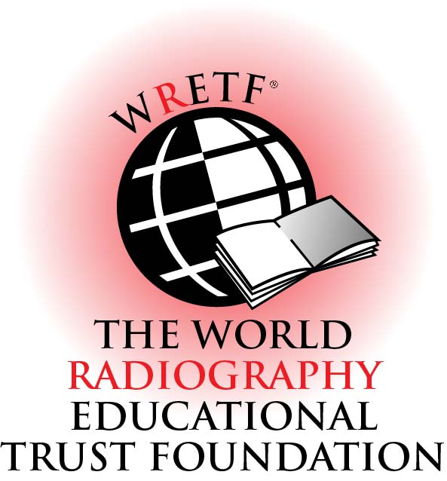
APPLICATION FORM
FOR CONFERENCE ATTENDANCE

PERSONAL DETAILS OF THE APPLICANT:

Title (Mr/Mrs/Ms/Dr)etc:
Family name:
Given (first) name:
Home address with postal(zip) code:

Work address with postal (zip) code:

Work address of employer with postal (zip) code:
Telephone number (home):
Telephone number (mobile):
Telephone number (work):
Email address:
Professional qualification(s):

Current job title with role and responsibilities (summary):

CONFERENCE DETAILS:

Title of conference
Indicate type of conference: eg international, national, regional, local.

Venue and dates of conference
Name of the organisation running the conference with website details

List outline of Conference content
(provide web site)

Describe your purpose for attending this conference. What are your key areas of interest and which key activities do you plan to attend? (Max 100 words)

Are you planning to present at the Conference. If Yes, please provide details

Give details of how you will personally benefit from attending the conference (Max 100 Words)

Give details of how your department will benefit and how you intend to share the knowledge gained (Max 100 words)

Give physical details of your department.. Describe under the following criteria.
*Size of hospital (no of beds)
*Type of hospital (Urban, regional or remote)
*Number of radiography staff
*List main equipment and modalities included (eg. general diagnostic; CT, US, MRI, Radiation Therapy, interventional, cardiac cath.)
*Image Processing (analogue/ digital)
*Archiving and Information Systems

Provide Name of Chief Radiographer/Radiation Therapist

Provide Name of Head of Imaging / Therapy Department
Provide letter of support from Chief Radiographer or Head of Dept. and names of two referees with contact details
Attach letter to application
Provide evidence of previous attendance/ involvement at conferences (CV or listing)

FINANCIAL DETAILS

CONFERENCE | DESCRIPTION | COSTS
Registration
Accommodation
Travel (Itemise)
Special fees for activities (Describe)
 |  | Amounts requested
On behalf of the department/school/association I am applying for support in the following areas:  (Check only those boxes which are relevant to this application) | Educational material –(please list type of material required)
 | Financial assistance to travel
 | Translation of educational documents
 | Support for conference Registration
 | Support for special activities
Itemise any financial contributions from other named organizations

Signed:
Date:

Please let us know how you heard of WRETF and the bursary scheme

Completed application form to be returned by email to:
susanmarchant@wretf.org

Or by post to:Miss S. Marchant, General Manager WRETF, 143, Corfield Street, Bethnal Green,
London. E2 0DS, UNITED KINGDOM

